January/February 2017 Newsletter

The Double Nickel
VIETNAM VETERANS OF AMERICA
CHAPTER 55
P. O. BOX 624
NEWARK, OHIO 43058-0624
740-927-6272

President: Mark Rehl: 740-364-9914

Interim Vice: David Neudecker 740-334-2826

Secretary: Rick Armstrong: 740-745-7049

Treasurer: Gary Evans: 740-343-4318

Board of Directors: Jack Bickley, Dale Bradshaw, Tim Caldwell, Mike Deible, Mick Dunlap, Larry Frazee, Gary Jones, Mike Kirk, Jim Lawrence, Rick Price, Dave Shoemaker, Bob Steen, Mike Swan
Editor: Patricia Rose, Public Relations 740-641-4616 (prose0334@gmail.com)
Website – vvachapter55newark.wix.com & Facebook – Vietnam Veterans of America Chapter 55

Greetings fellow Veterans and families.
As 2016 comes to a close we all need to take time to reflect on the past year. Remembering those that have passed on to the other side of THE WALL should be part of this process. Chapter 55 lost MSGT Lauren Eastwood, USAF Retired. Lauren was a Board of Directors member and attended many Chapter 55 activities until his failing health finally restricted his ability to get out and about. Chapter 55 has been very fortunate in this area considering the many health issues that our members are dealing with.
As I stated in the last newsletter 2017 is an election year. Nominations will take place on 6 February 2017 at the regular membership meeting with elections being held on 6 March 2017. Installation will be at the 3 April 2017 meeting. If you are interested in holding an office you must either be at the February meeting or file a letter of intent with the election committee. The deadline for letters of intent will be 1 March 2017.
Recently I undertook a project to increase the membership of Chapter 55. For several years I have been trying to get our membership over the 150 man/woman mark. We came very close a couple of times but could never attain my self-imposed goal. What turned the corner? I finally got a list of "at large members" in our area from VVA Buckeye State Council. At large members are members of VVA who do not have a Chapter designation. I sent out an introductory letter, a transfer form and a self-addressed, stamped envelope to each of these individuals. The response has been such that not only do we now have 150 members but we are rapidly approaching the 160 member mark. There are still several more potential transferees and I will keep up my efforts to "bring them into the fold".
I have kept a master list of all Chapter 55 members including transfers out of the Chapter, deceased members and members that have let their membership lapse. If we could bring back even half of those who have dropped out of the VVA our membership would be in excess of 175 members - probably pushing 190 members.
At this time I would like to welcome new members:
Douglas Lynn - LIFE, Larry Cope, Tim Ritchey - LIFE, Mark Williams - LIFE, Terry Pierce - LIFE, Harold Haldeman - LIFE, Brig. Gen. Steve Martin, ANG Retired, Preston Hale - LIFE, Michael Ruffner and Ronald Nordman. AND I AM STILL WAITING ON RESPONSES FROM 14 MORE POTENTIAL TRANSFEREES!
I would like to take this opportunity to thank all of the Chapter 55 members and their families for their efforts in this past year. You are the heart and soul of this Chapter.
As we venture into 2017 I hope all is well with you and your families.
Mark A. "Squid" Rehl - President
To all of you: MAY YOU HAVE FAIR WINDS AND FOLLOWING SEAS
MEMBER FEATURE – Greg Jarvis

Greg Jarvis was born in Columbus, Ohio. He graduated from Gahanna Lincoln High School June 1967.

Greg joined the Army March 25, 1969 and went into Infantry and Airborne training before he went to Viet Nam in April 13, 1970.

He served with E/1/503 Infantry with the 173 Airborne, Bde, for a year until they were sent home. Greg extended for 6 months and went to E/3/503, 173 Airborne Bde until he was wounded.

Greg Jarvis retired from the Army June 22, 1971.

He is married to Nola and they have seven children (4 boys and 3 girls) and 15 grandchildren (4 boys and 11 girls).

The Jarvis’ live in Dresden, Ohio.

FOOTNOTE: If you would like to participate in Chapter 55 Member Feature, please send a brief bio to Pat Rose by email or give it to her, typed or handwritten, at one of the chapter meetings.



MEMBER Birthdays

January

Mike Blaney
Tony Decker
Brett Leffel
Richard Lennington
David Neudecker
Clarence Rutter
Roger Walters
Michael Williamson

February
Michael Bond
Linda Boyles
Dale Bradshaw
David Cullison
Robert Hull
Michael Kinkead
Thomas Miles
William Powell
Bruce Raymer
James Sanders
Steve Thagard
AVVA – Brittany Evans

FOOTNOTE: If you would like your birthday to be on file please get that info to Mark Rehl or Pat Rose.

ANNIVERSARY OF ENROLLMENT IN VVA

January years

Lester Abele 13
Gordon Cromwell 5
Larry Dillion 15
Robert Dingey 13
Terry Dugan 29
Gary Evans 11
Larry Frazee 20
Kathleen Harty 33
Greg Jarvis 34
David Karnes 7
Richard Miller 11
William Ohlinger 8
Joseph Stotski 21
Gary Stottsberry 3
Mike Swan 4
Michael Zaborowski 16

February years

Robert Bolton 4
Jack Drake 6
Craig Gallagher 4
Roger Jesse 26
Jerry Mears 7
John Meyers 1
Thomas Miles 3
Arthur Walker 16
AVVA – Dora Armstrong 10
Darla Bickley 2
Doris Eastwood 2

FEATURE – 2016 Veteran of the Year
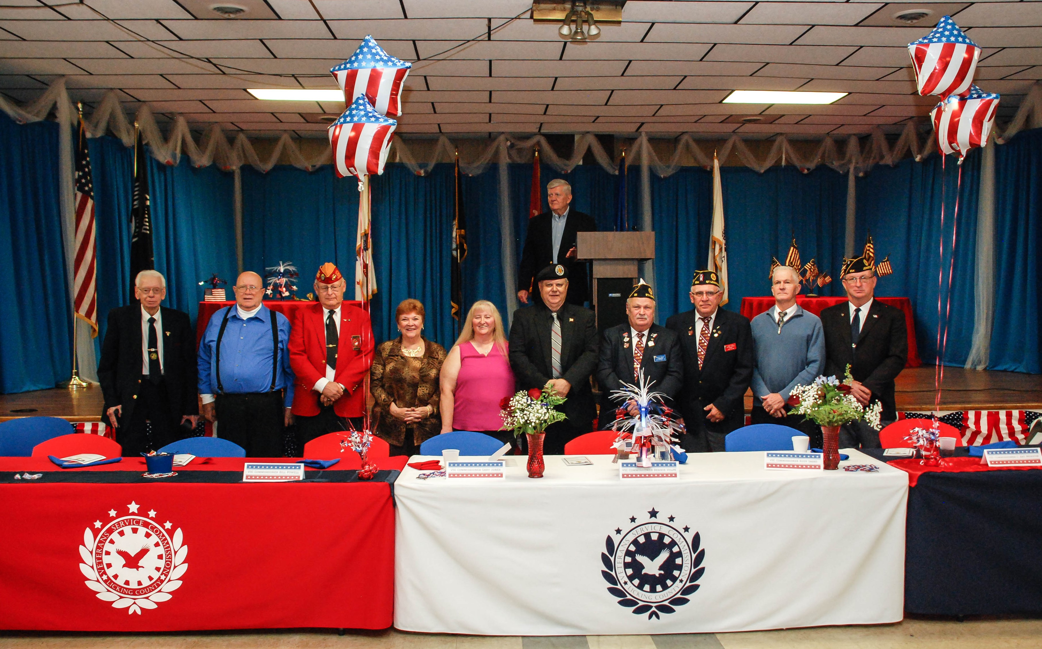

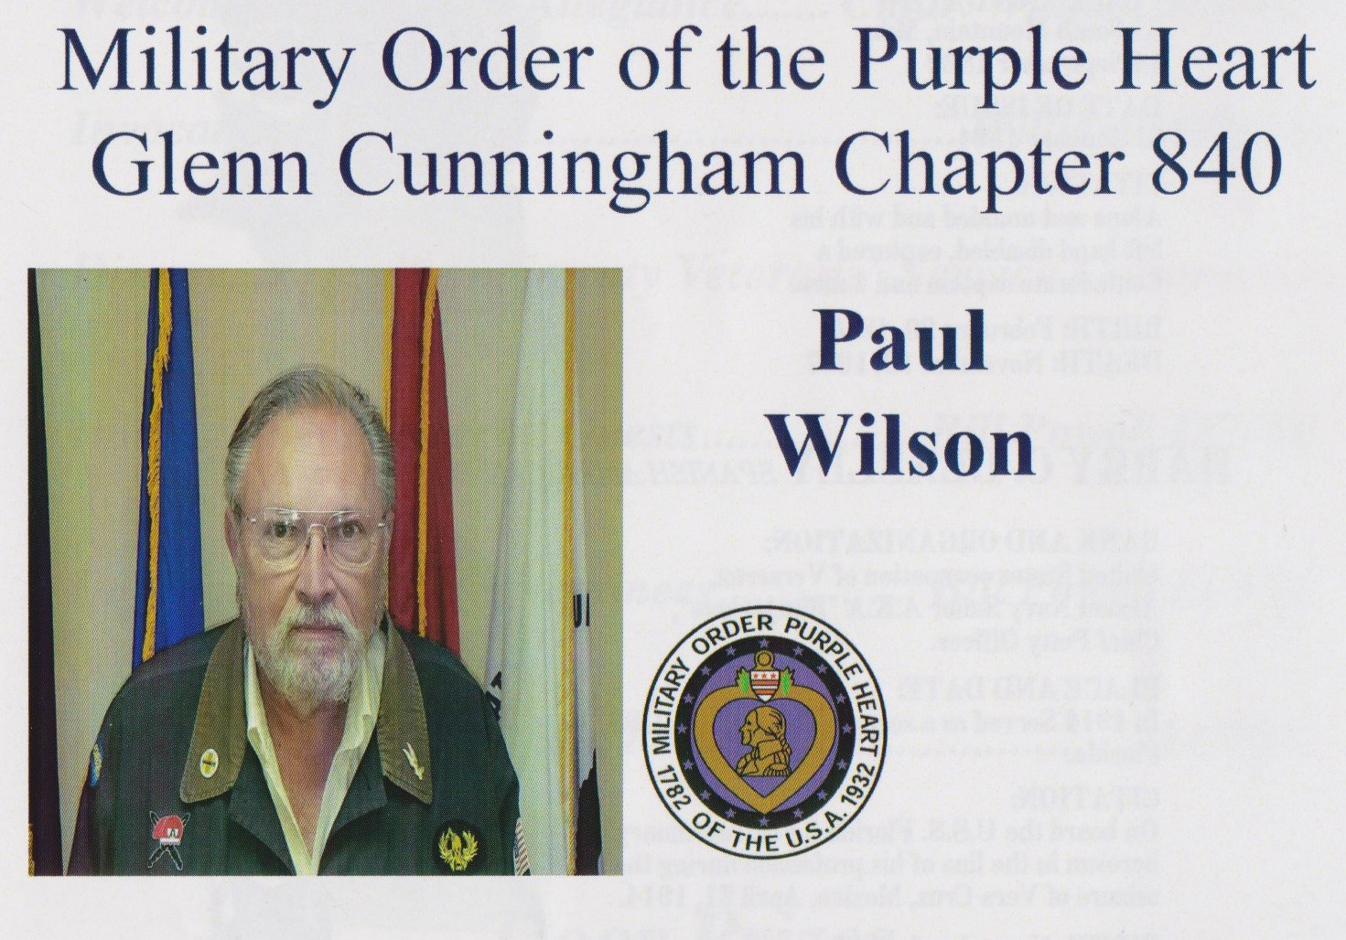

Chapter 55 member, Paul Wilson, was well deservedly awarded the 2016 Veteran of the Year. Paul was nominated by the Military Order of the Purple Heart, Glenn Cunningham Chapter 840.
2016 Veteran of the Year Nominees

Mr. Wilson, of Alexandria, is a veteran of the U.S. Army and served from 1966 until 1968. He is actively a member of several veteran’s organizations. Congratulations Paul.

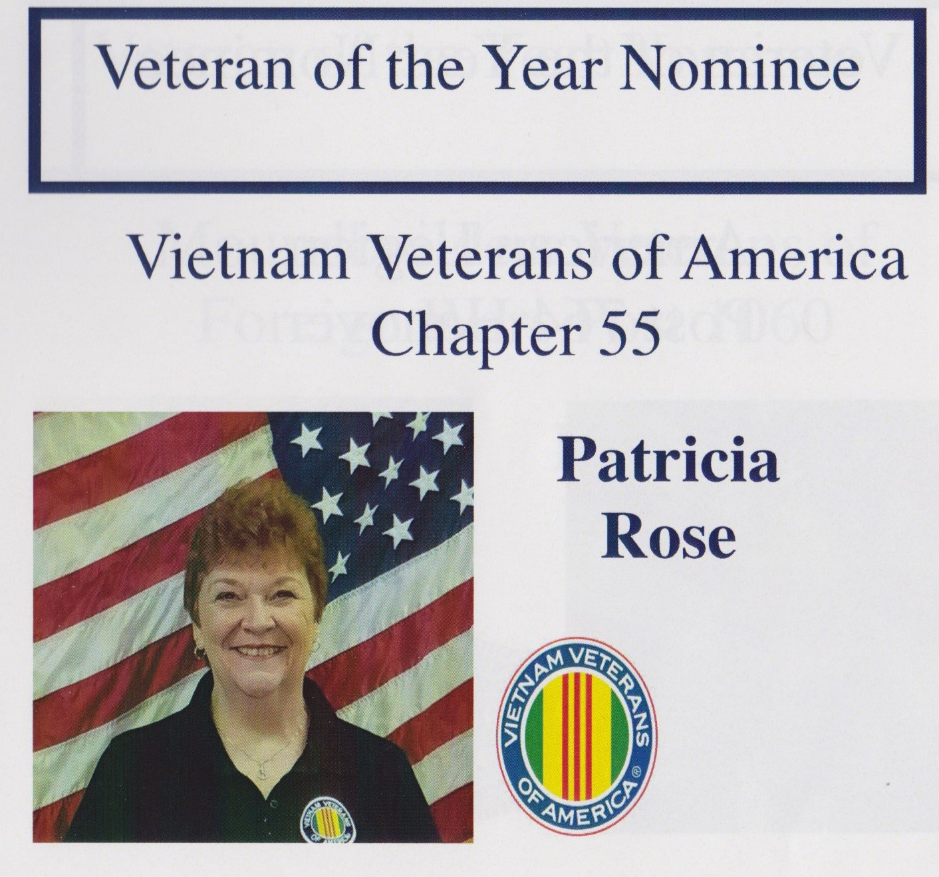

Only two women veterans have ever been nominated in Licking County for Veteran of the Year. And both were nominated this year.

This author would like to thank Chapter 55 for the privilege of being one of those two. Now the field is open for other veteran organizations to recognize women veterans for their service to the community.

Ms. Rose, of Newark, was a Navy Journalist during the Vietnam War era. She is active in several veteran and community organizations.

Congratulations to Chapter 55 for stepping up and breaking that glass ceiling.

VETERANS IN THE KNOW – Liver Flukes
The Department of Veterans Affairs (VA) recently acknowledged that certain diseases showing up in Vietnam veterans is directly linked to Liver Flukes.

Thousands of veterans from the Vietnam era are coming down with rare cancers, many of which are the results of veterans having consumed parasitic fish while serving in Vietnam. The VA is seeing an increase in bile duct cancer, cholangiocarcinoma, and liver cancer amongst Vietnam era veterans.

What Are Liver Flukes?

Liver flukes are parasites ingested in raw or undercooked freshwater fish. They are endemic in parts of Southeast Asia, including Vietnam, along with other areas, mainly in China and South Korea. Some 25 million people are infected with the worms. Liver flukes die when frozen, but they can survive fermentation or pickling. Visitors traveling in endemic areas can also be infected.

What is Cholangiocarcinoma, and How Do Liver Flukes Cause It?

Cholangiocarcinoma is a rare cancer that affects the bile duct. Liver flukes are a risk factor; others include hepatitis B and C, cirrhosis and bile duct stones. After the worms are ingested, they can live for more than 25 years in the bile duct, causing inflammation and scarring that can eventually lead to cancer. The disease is difficult to treat, with many victims dying within months of diagnosis. A patient typically does not experience any symptoms, such as jaundice, until the end stages.

Can This Cancer Be Treated?

Bile duct cancer is unusual because it can be prevented in some cases. Pills can wipe out liver flukes early on, but the medicine is not effective in later stages after the worms have died and scarring has occurred. Surgery is possible in some cases, but the survival rate is only about 30 percent for five years, said Dr. Gregory Gores, a gastroenterologist and executive dean of research at Mayo Clinic. Affected countries, such as Vietnam and Laos, have not conducted extensive research to determine the extent of the problem. The world's highest rate of cholangiocarcinoma - about 84 new cases per 100,000 people - is found in northeastern Thailand where many people eat a popular raw fish dish. In the U.S., cholangiocarcinoma is extremely rare, with around 1.7 in 100,000 people diagnosed each year.

What Is The Connection to Vietnam Veterans?

Men and women who served in the Vietnam War and ate raw or poorly cooked fish, sometimes while on patrol in the jungle after their rations ran out, could have been infected by liver flukes. Left untreated, they can experience symptoms related to bile duct cancer decades later. Because the disease is so rare and awareness about liver flukes is poor in the U.S., many veterans may not be aware of the possible connection to their service time.
Are Veterans With This Condition Eligible for Financial Compensation?
Each case reviewed by VA is examined individually and of its own merits, and it’s up to each veteran to prove to VA that their cancer is “as likely as not” related to their service time. The VA says fewer than 700 cholangiocarcinoma patients have passed through its medical system in the past 15 years. In part because they are unaware of the potential link to their war days in Vietnam, only 307 of the veterans submitted claims for benefits over that period. Even though the VA sometimes approves the link between wartime service and cholangiocarcinoma, the vast majority of claims, 3 out of 4, are rejected.

2017 EVENT SCHEDULE
(All events subject to be added and/or changed)

March
- 6 – annual Veteran of the Year and Distinguished Service awards, Election of Officers

April
- 4- Swearing in of new officers

May
- 20 - 22 Findlay Armed Forces Celebration
- 28, 29 & 30 - Memorial Day weekend coffee break

June
- 14 - Flag Day

July

- 4th Parade
September
- 2, 3, & 4 - Swappers Day, Sportsman’s Club Drive
- POW/MIA Vigil, Reynoldsburg
- Chapter 55 picnic/party TBA

November
- 11 – Veteran’s Day
- Thanksgiving Baskets delivered

December
- Wreaths Across America
- Chapter 55 Christmas dinner/Secret Santa TBA

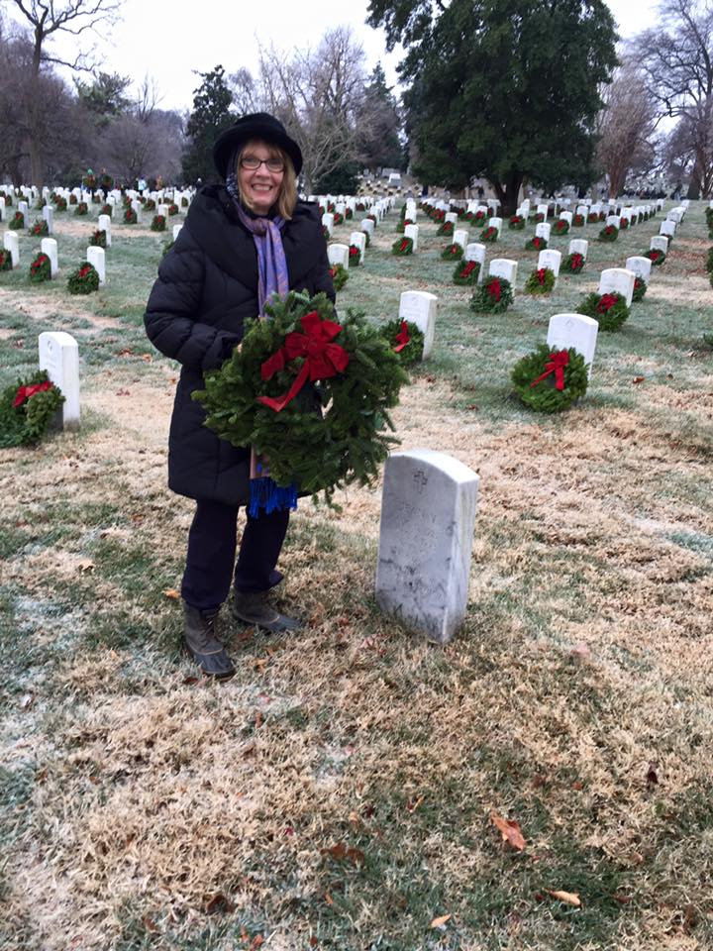

Above: Chapter 55 Member Debby Millerberg traveled to Arlington Cemetery to help lay wreaths on the graves of our nation’s heroes. Thank you Debby for your service.
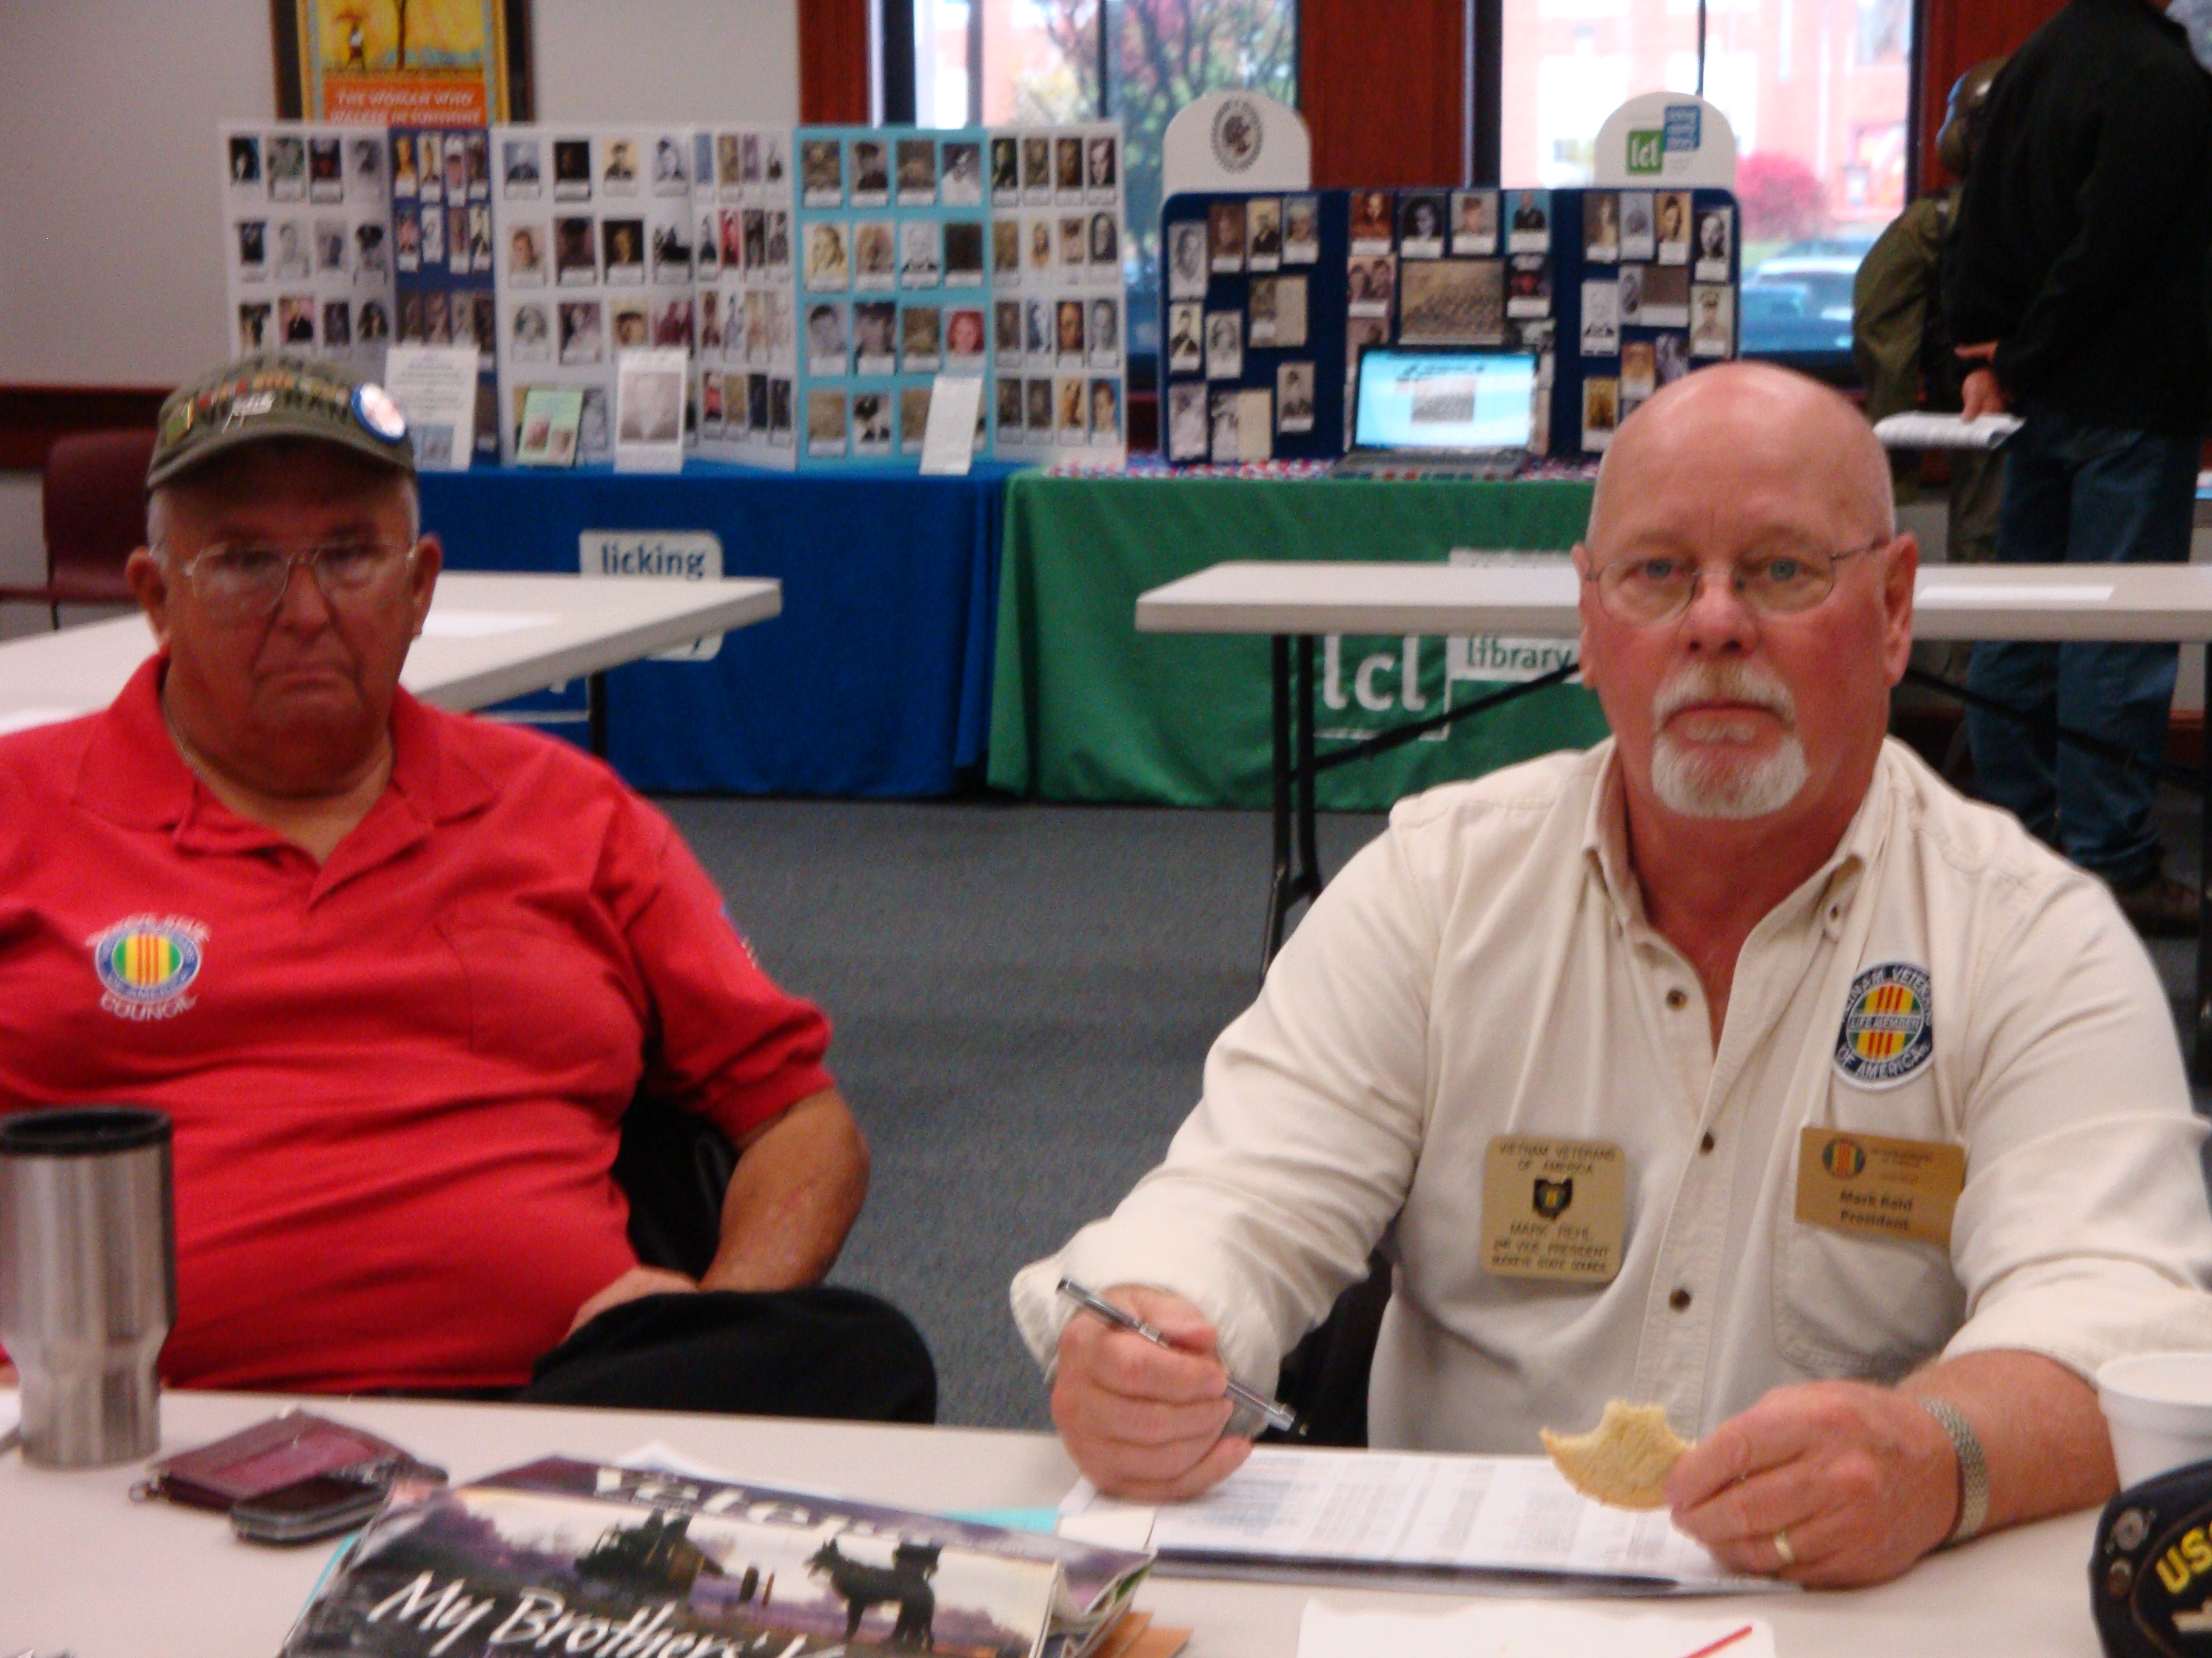
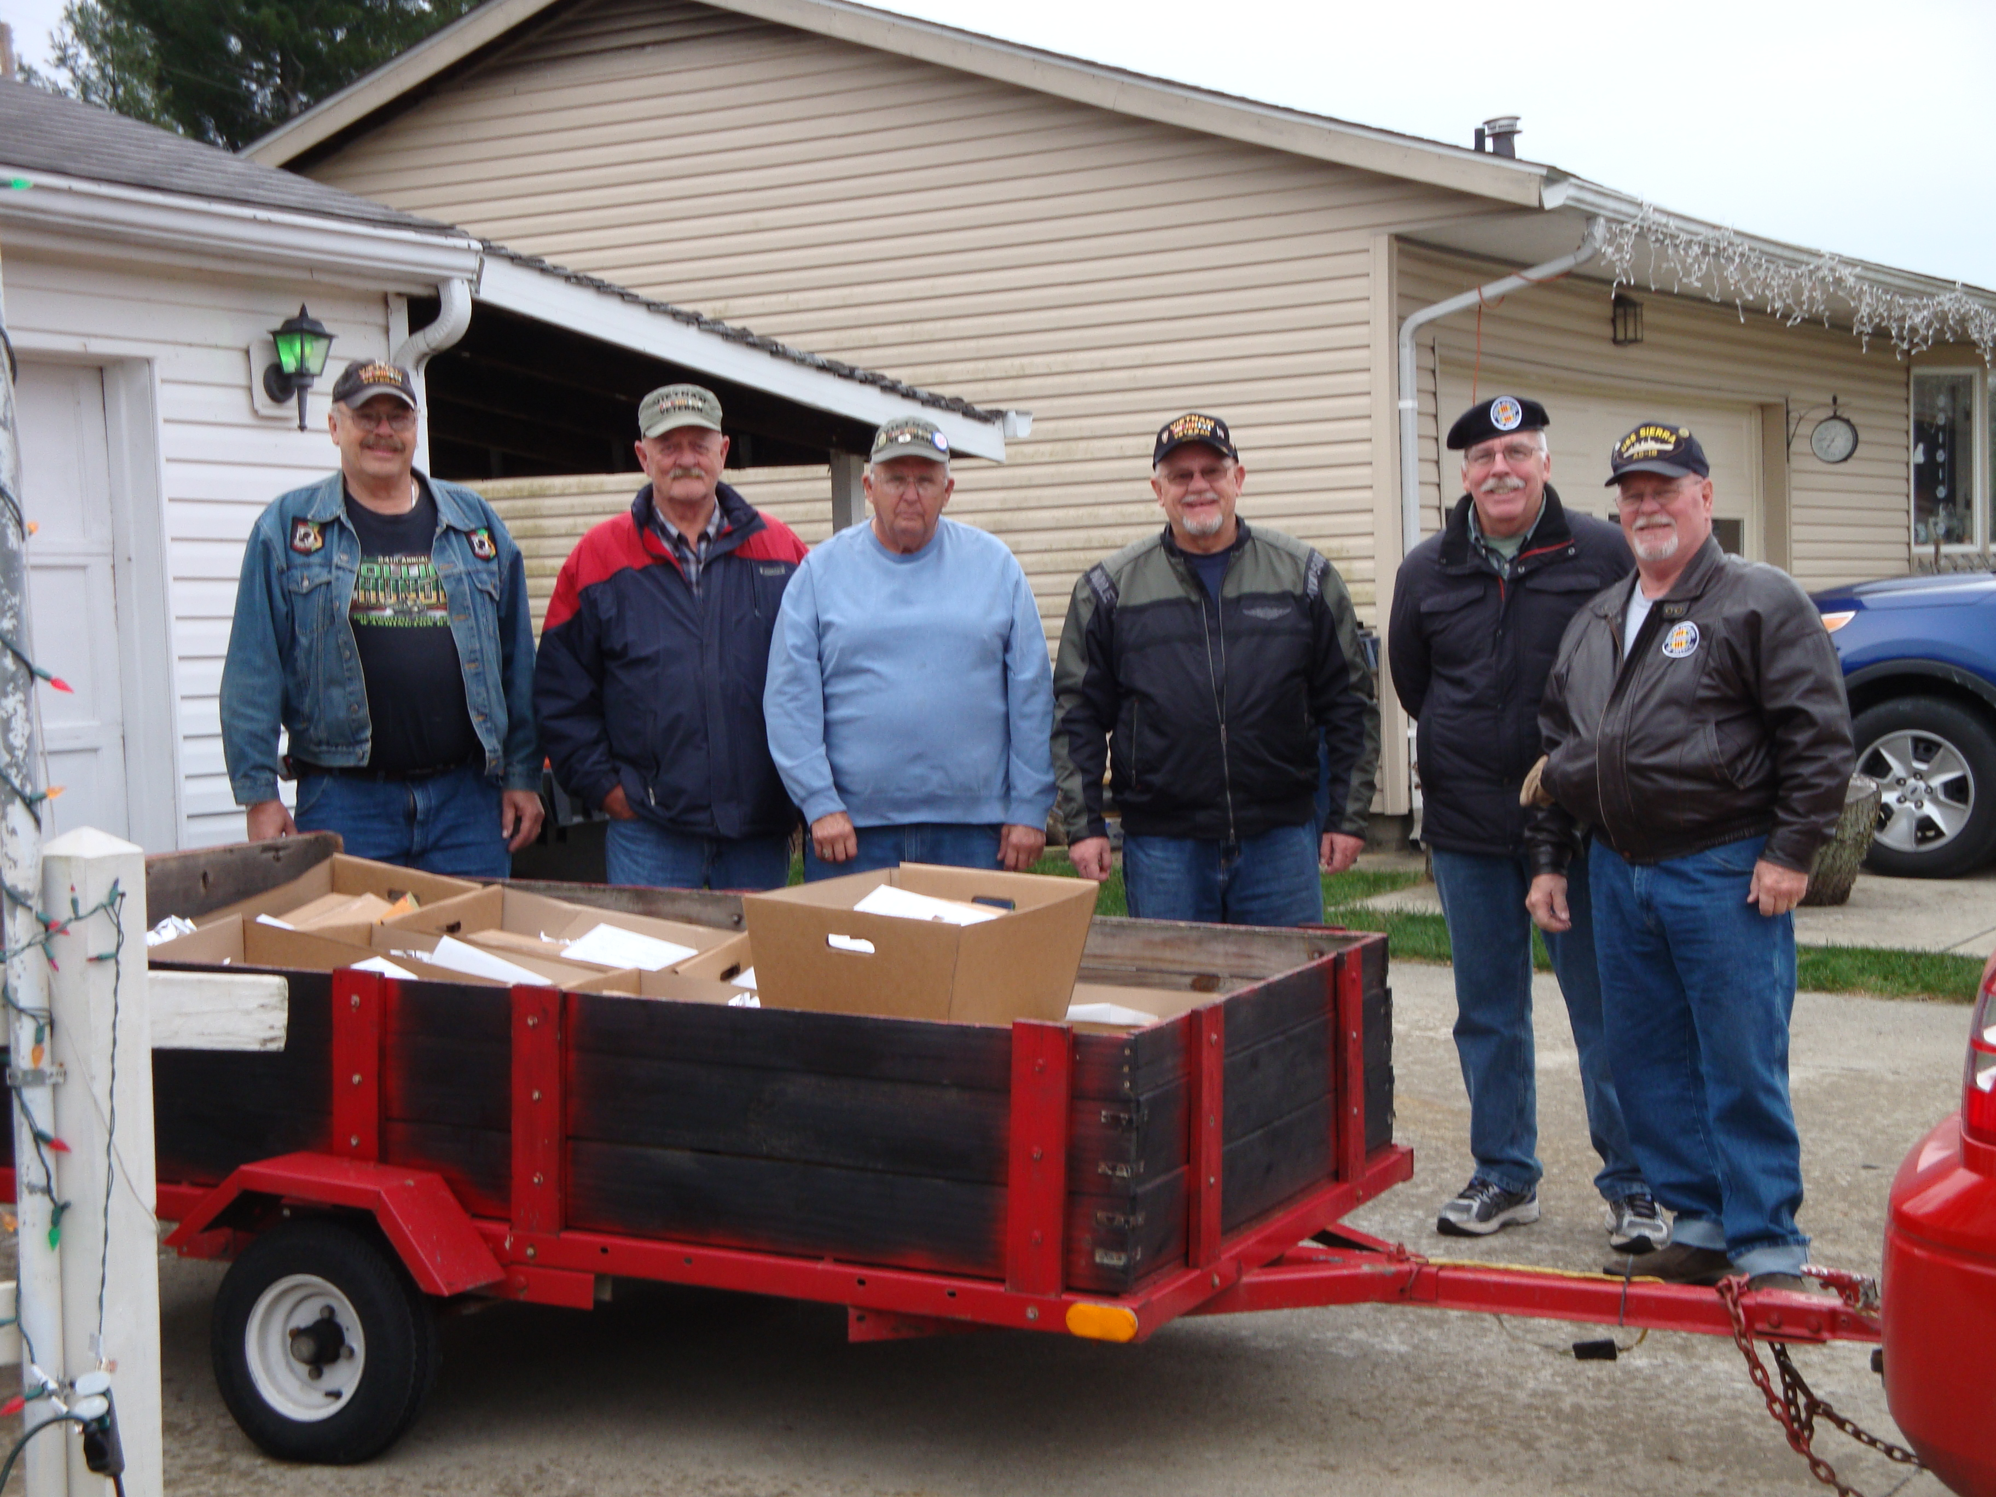

Above: Rick Armstrong (Chapter 55 Secretary) and Mark Rehl (Chapter 55 President) at Nov. 10th Veteran’s Expo at Library
Above: Thanksgiving dinner deliveries. Thanks to those who took time from their busy holiday schedules to participate. David Neudecker, Mick Dunlap, Rick Armstrong, Dan Webb, Paul Mike Wilson, Mark Rehl, and Pat Rose.

Below: Kathleen Harty, Chapter 55 member at same Expo representing the Genealogical Society.

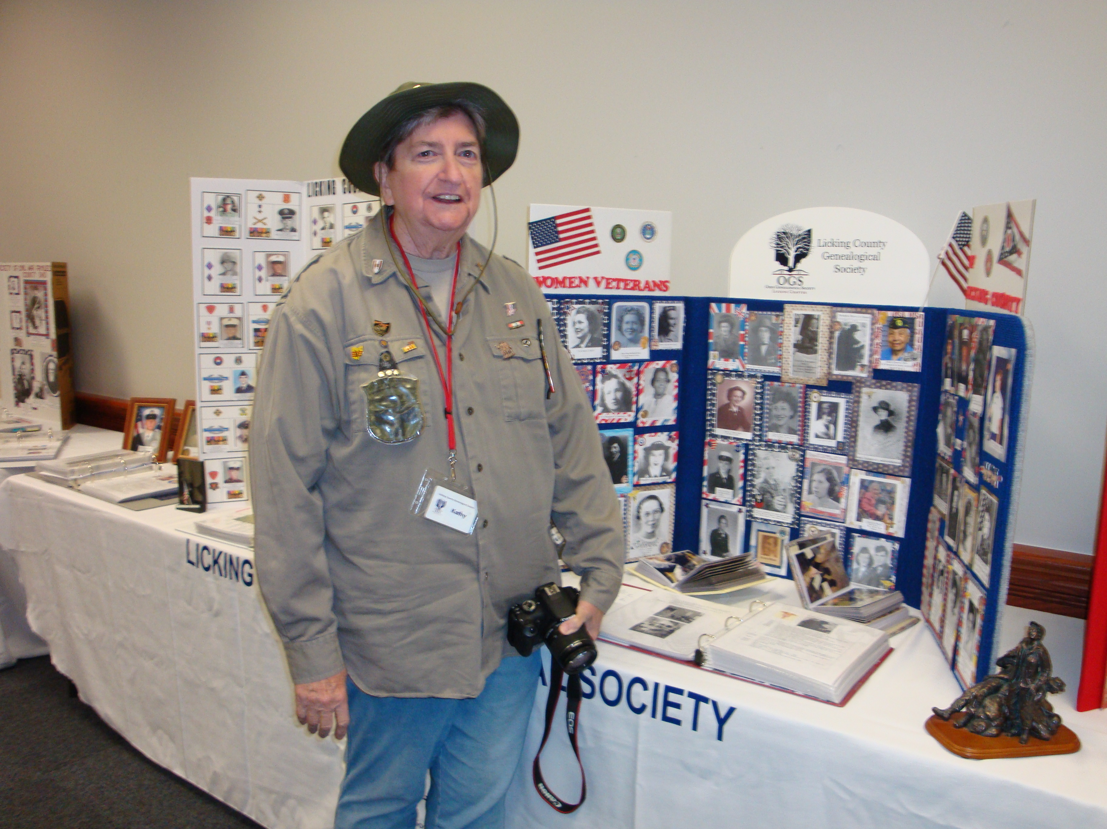
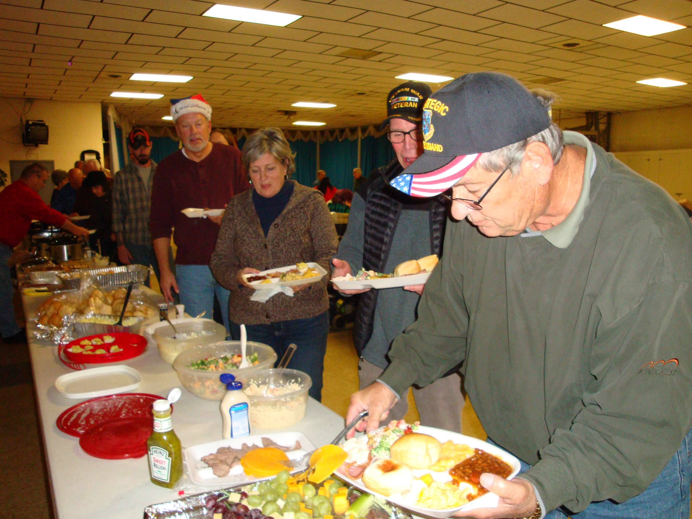

Below: Chapter 55 participates in Freedom’s Never Free Korean Traveling Wall Memorial in Lancaster November 2016.
Above: Chapter 55 Christmas Dinner on December 5th. Great food and great friends

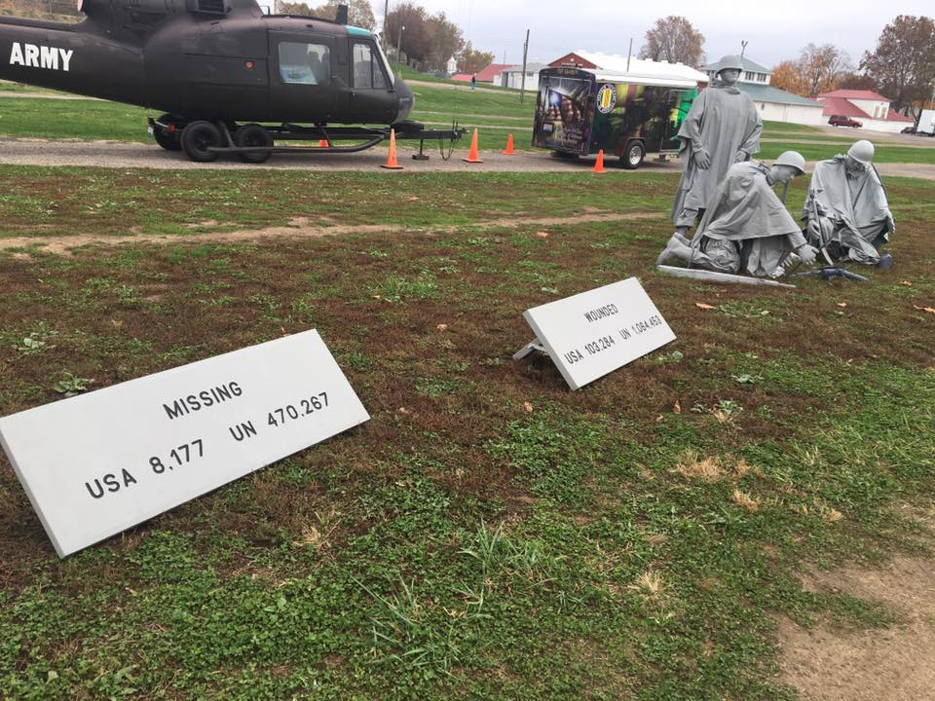

MEETING DATE FOR 2017

Meeting at: VFW on Forry Ave., Newark, OH
(First Monday of the month rule)
** Bold month is exceptions to the rule**

January 2 July 3
February 6 August 7
March 6 September 11
April 3 October 2
May 1 November 6
June 5 December 4

